

BRP

User Manual

LF-BRP-UM-EN

v1.2
NOVEMBER 2025

www.liftena.com
DOCUMENT REVISION HISTORY

İS NAME İM | TITLE | TITLE | DATE
Prepared by
M. Uygar AKGÜL | General Manager |  | 18.11.2025
Checked by
M. Uygar AKGÜL | General Manager |  | 18.11.2025
Approved by
M. Uygar AKGÜL | General Manager |  | 18.11.2025

DOKÜMAN YAYIN ÇİZELGESİ

Revision No | Date | Section/Page Modified | Reason
1.1 | SEP 2025 | Entire Document | First Release
1.2 | NOW 2025 | Entire Document

INDEX

1 GENERAL FEATURES 5
2 SYSTEM OVERVIEW 6
3 TECHNICAL SPECIFICATIONS 7
3.1 Input Supply 7
3.2 Output Options 7
4 TERMINOLOGY 8
5 DİMENSİONS (in mm) 9
6 NOTES 9
7 APPENDICES 9

GENERAL FEATURES
The BRP is a coil voltage regulation module designed with flexible options to prevent brake/regulator coils from being continuously exposed to high current

SYSTEM OVERVIEW
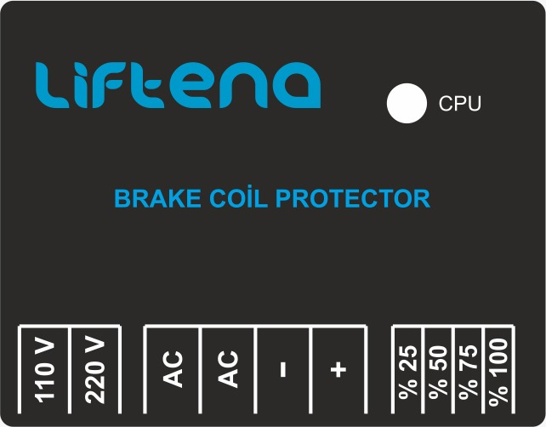
Şekil 1 Genel Görünüm

TECHNICAL SPECIFICATIONS

Input Supply

Özellik | Açıklama
Supply Voltage | 220VAC

Tablo 1 Input Supply

Output Options
Anahtar 1 | Anahtar 2 | Açıklama
220V | %100 | Output starts and continues at 220V
220V | %75 | Output starts at 220V, drops to 170V after 3 seconds
220V | %50 | Output starts at 220V, drops to 110V after 3 seconds
220V | %25 | Output starts at 220V, drops to 55V after 3 seconds
110V | %100 | Output starts and continues at 110V
110V | %75 | Output starts at 110V, drops to 75V after 3 seconds
110V | %50 | Output starts at 110V, drops to 55V after 3 seconds
110V | %25 | Output starts at 110V, drops to 35V after 3 seconds

Tablo 2 Output Options

TERMINOLOGY
Rumuz | Açıklama
AC | 220 VAC Input
AC | 220 VAC Input
- | Output Negative Terminal
+ | Output Positive Terminal
Tablo 3 Terminal Names

DİMENSİONS (in mm)
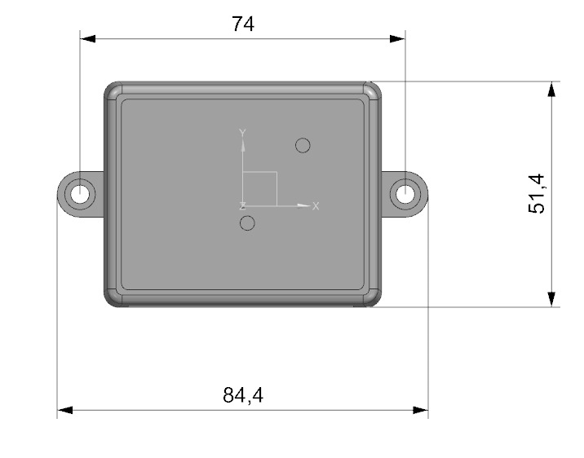

NOTES
None

APPENDICES
None.

